Assignment-4.3

Name:Divya Batch:14

Rollno:2403a51356

**Task Description#1**

* Zero-shot: Prompt AI to write a function that checks whether a given year is a leap year.

**Expected Output#1**

* AI-generated function with no examples provided

Prompt:

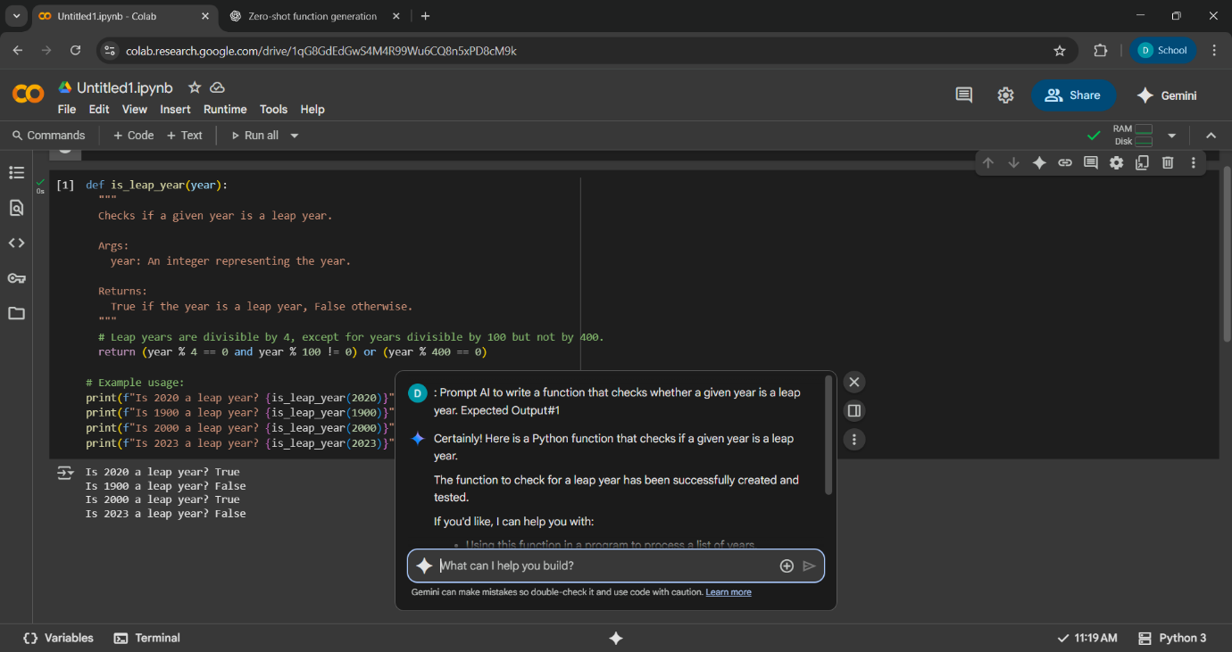

Code with output:

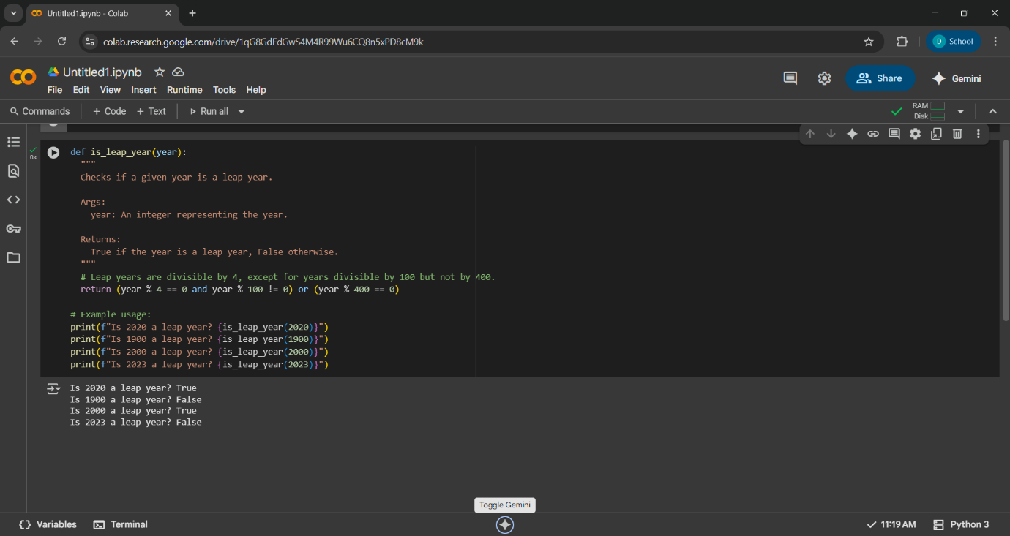

Observation:

The function checks whether a given year is a **leap year**. This zero-shot code correctly implements the leap year . It follows the standard rules of the **Gregorian calendar**, and the logic is compact and efficient.

In this code we have 4 test cases (4 examples )give the correct output.

**Task Description#2**

* One-shot: Give one input-output example to guide AI in writing a function that converts centimeters to inches.

**Expected Output#2**

* Function with correct conversion logic

Prompt:

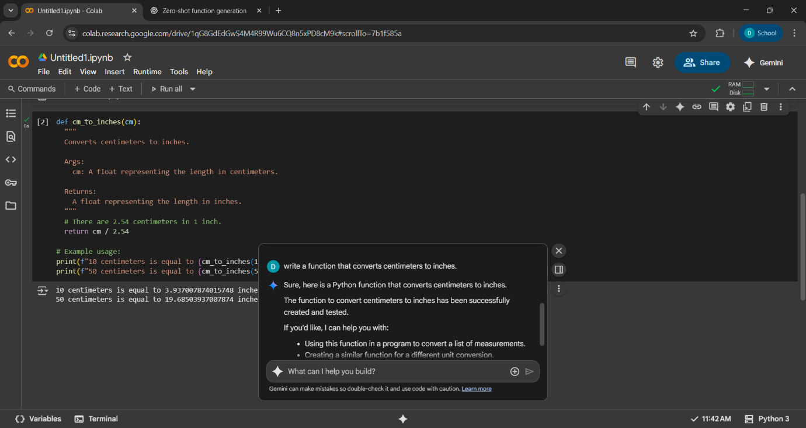

Code with output:

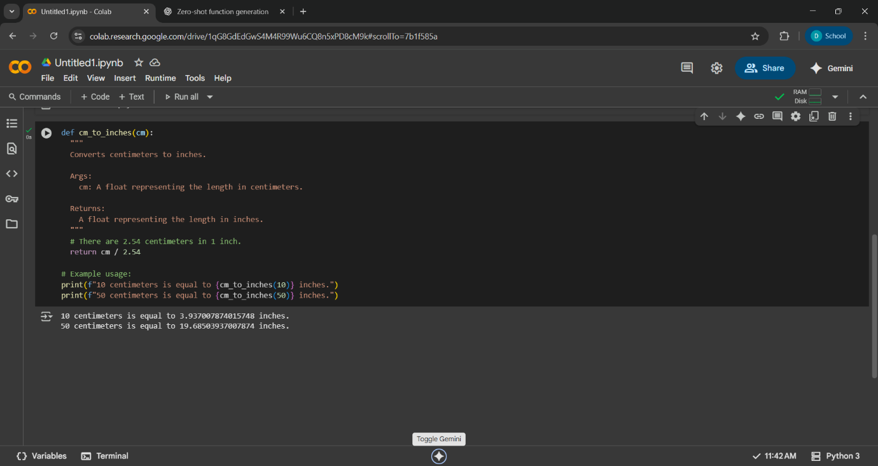

Observation:

1. The function cm_to_inches(cm) converts a length given in centimeters to inches.

2.This is correct code because **1 inch = 2.54 centimeters**. The function

divides the input centimeters by 2.54 to convert it to inches.

3.The code correctly converts centimeters to inches. It is well documented, easy to understand, and outputs accurate results.

**Task Description#3**

* Few-shot: Provide 2–3 examples to generate a function that formats full names as “Last, First”.

**Expected Output#3**

* Well-structured function respecting the examples

Prompt:

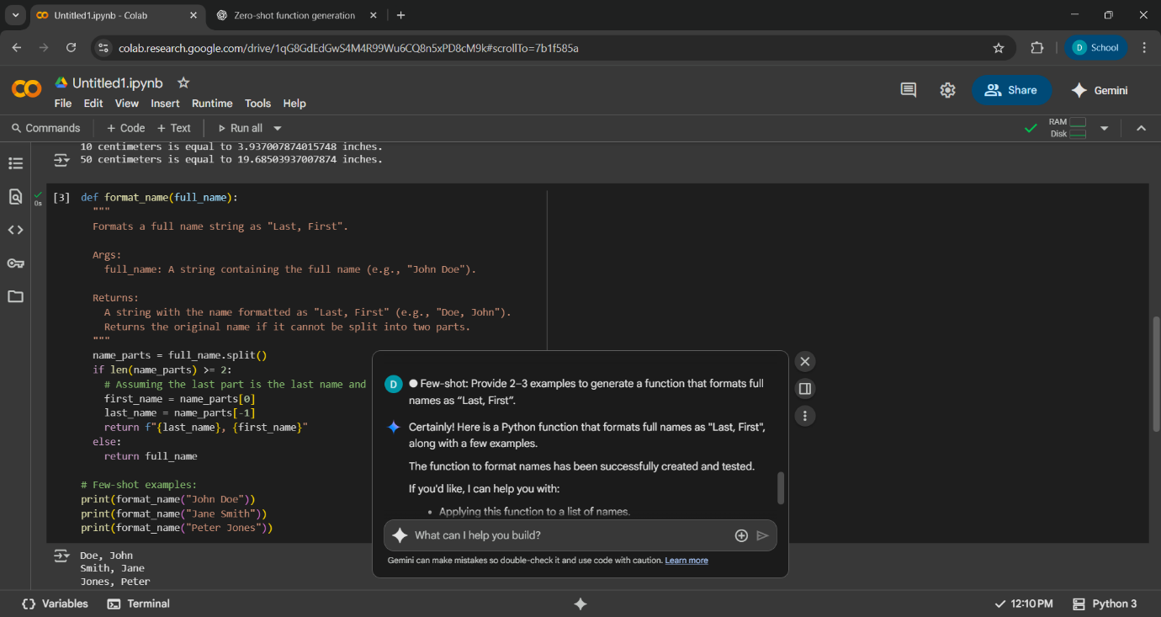

Code with output:

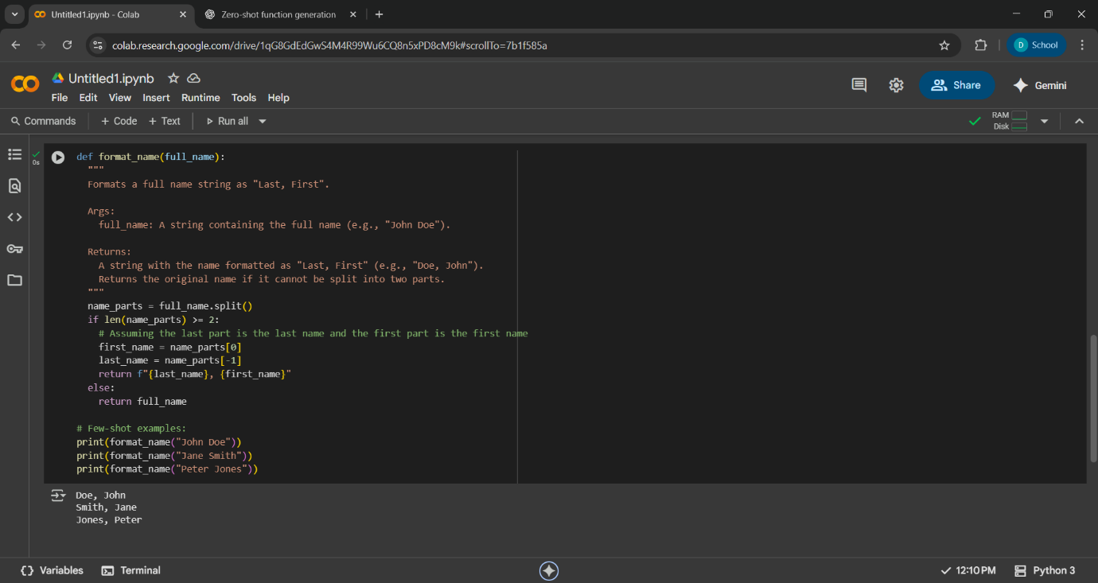

Observation:

* It splits the input name into parts using spaces.
* If there are at least two parts, it assumes the first part is the first name and the last part is the last name, then returns them in the format "Last, First".
* If the input cannot be split into two parts(eg,only one word),it returns the original name.
* The few shot examples demonstrate the function with typical two part names.

**Task Description#4**

* Compare zero-shot and few-shot prompts for writing a function that counts the number of vowels in a string.

**Expected Output#4**

* Functional output and comparative reflection

Prompt:

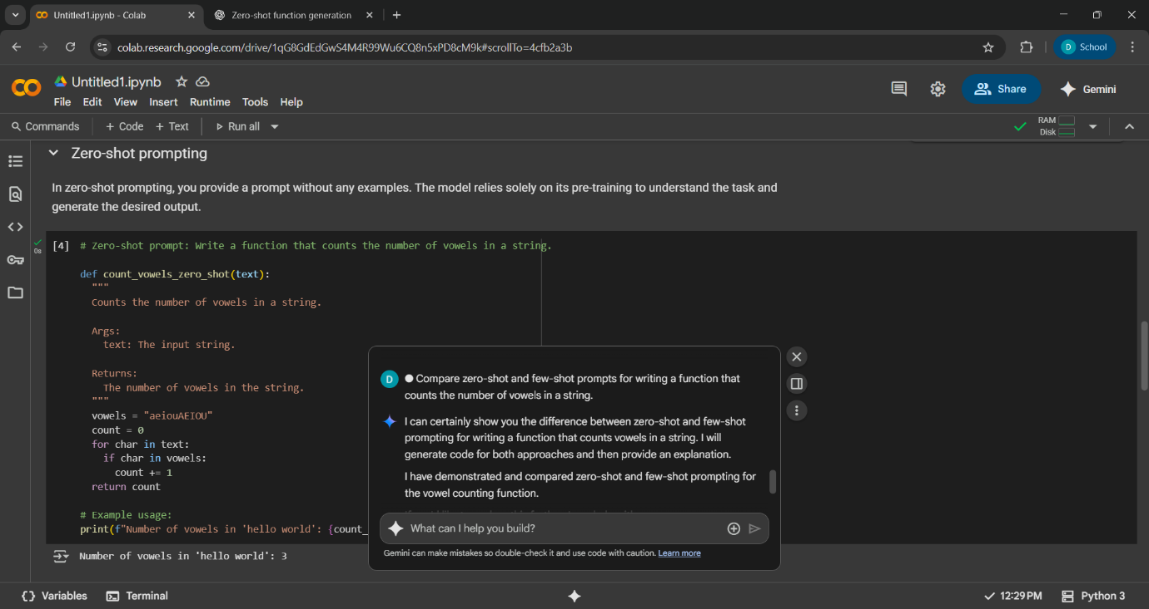

Code with output:

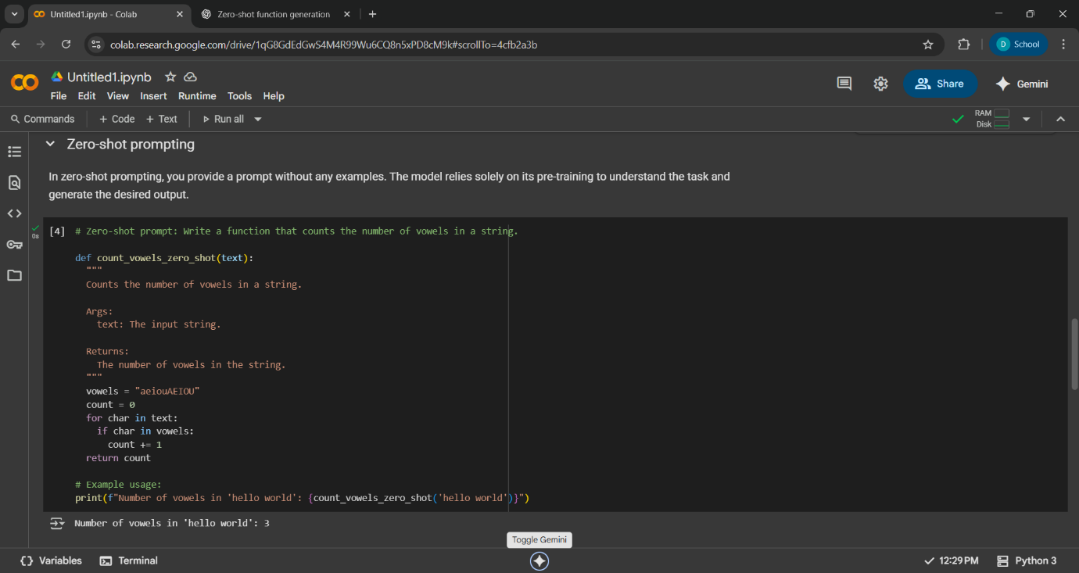

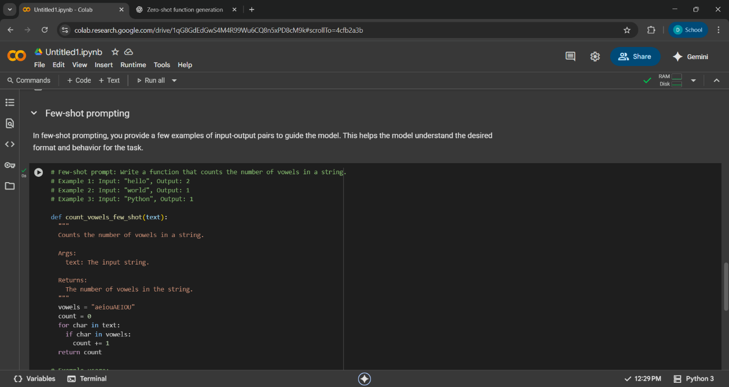

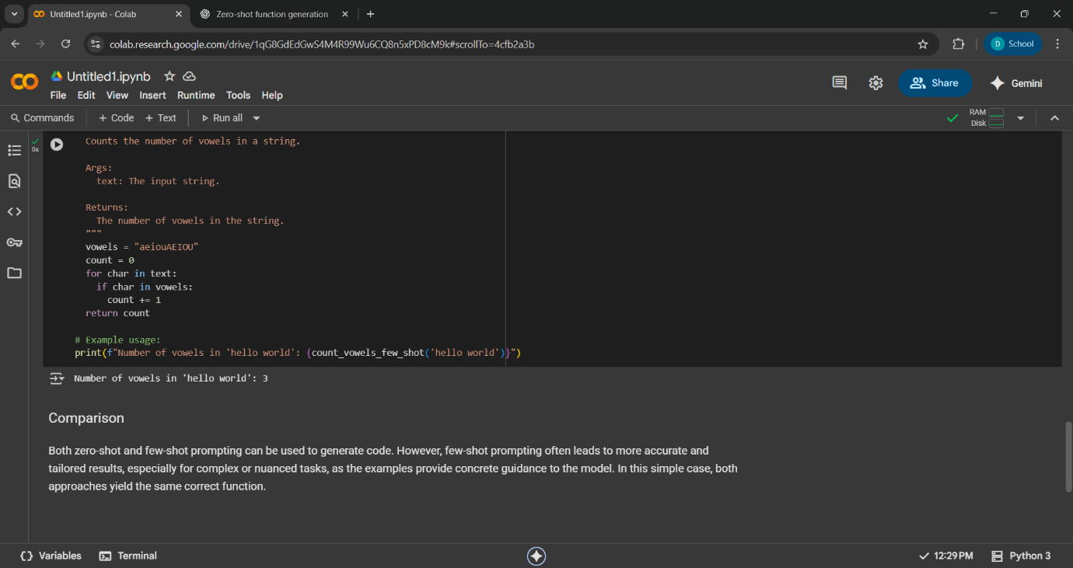

Comparison:

Both zero-shot and few-shot prompting can be used to generate code. However, few-shot prompting often leads to more accurate and tailored results, especially for complex or nuanced tasks, as the examples provide concrete guidance to the model. In this simple case, both approaches yield the same correct function.

Observation:

The code define a pythonfunction count_vowels_few_shot that takes a string as input and returns the number of vowels (both lowercase and uppercase) in that string.

The code then demonstrates the use of this function with the input string 'hello world' and correctly prints that the number of vowels in this string is 3.

**Task Description#5**

* Use few-shot to generate prompting a function that reads a .txt file and returns the number of lines.

**Expected Output#5**

* Working file-processing function with AI-guided logic

Prompt:

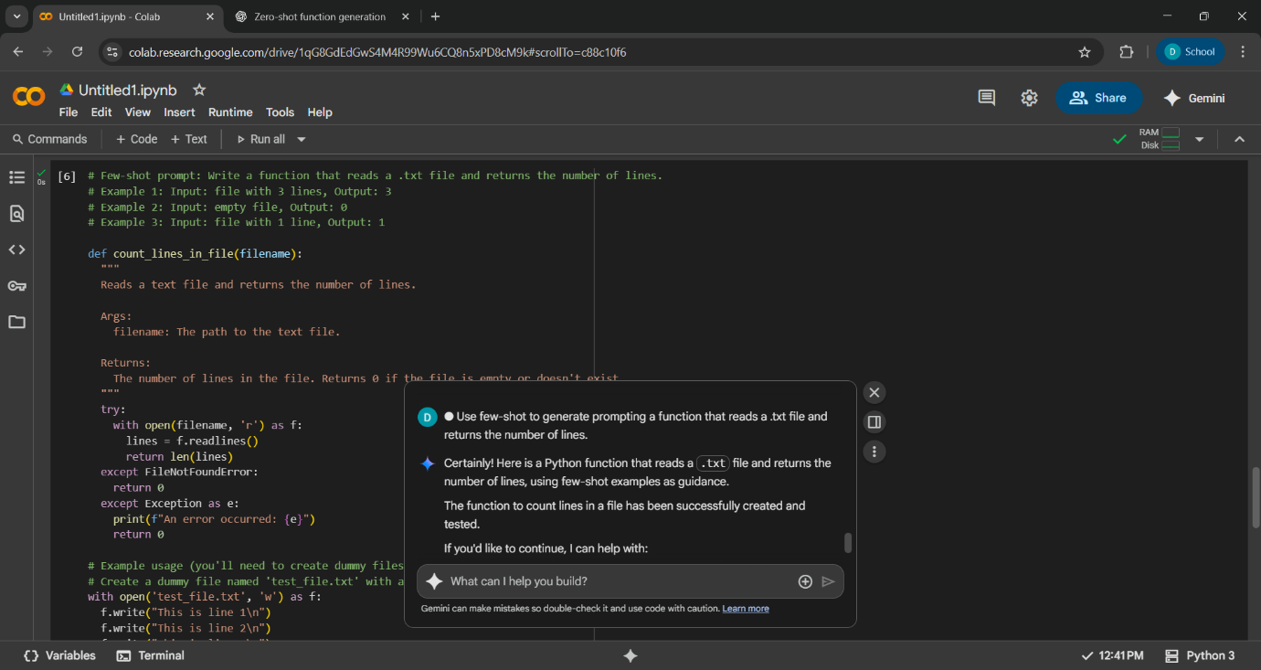

Code with output:

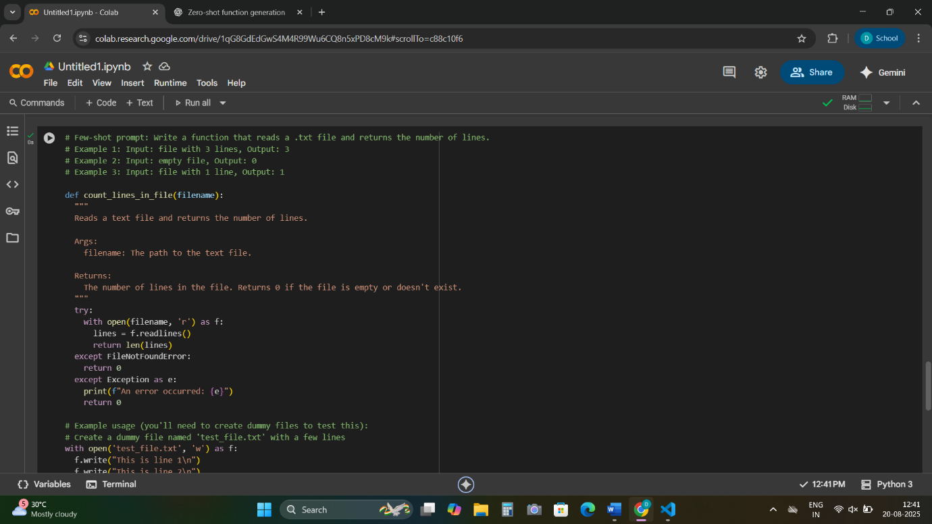

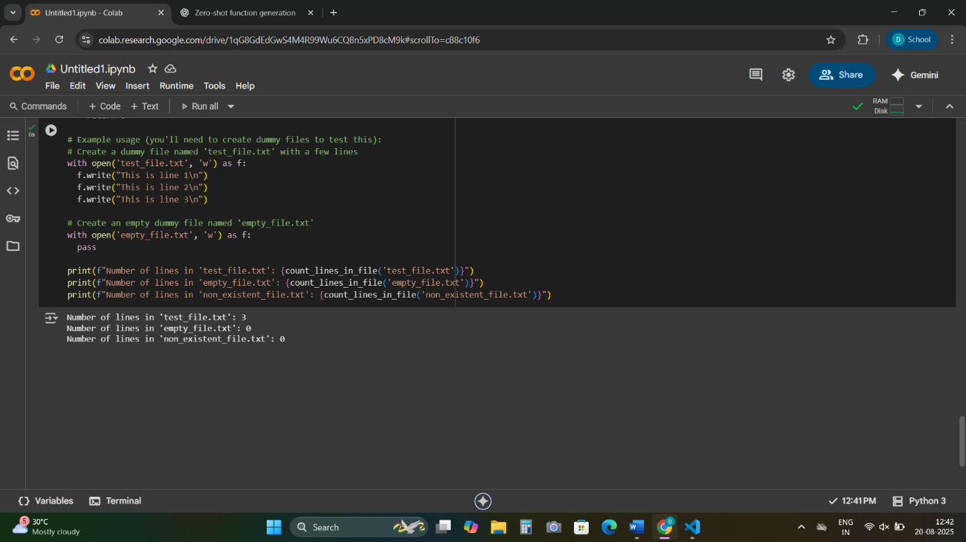

Observation:

* 1. The function reads a text file and returns the **number of lines** it contains. If the file is **empty** or **does not exist**, it returns 0.

2.A string representing the **path to the text file**.

3.Opens the file in **read mode**. Returns the **length of the list**, which equals the number of lines.

It covers both **valid input** and **error scenarios**.